User Guide for Student Claims
Things to provide (all in 1 PDF):
- PI’s approval *please also indicate WBS no. for expenses that are not part of your PhD allowance
- Conference Programme itinerary OR academic visit invitation letter
- All receipts with purpose of the expenses clearly stated eg. transportation from airport to hotel, conference name, etc.
- Alternative to receipts (must provide both items):
- Invoice/order confirmation to show details of purchase
- Proof of payment (eg. Bank/ Credit card statement addressed to your name)
*Note: Kindly block out personal transactions for PDPA purposes. Only the following details need to be included in the statement:
1. Your name
2. Last 4 digits of the bank account/credit card number
3. Line item showing your purchase
- For airfares booked on your own, attach FCM Travel quotation as comparison
- For per diem calculation, use attached excel calculator (Footnote e)
- For foreign currency transactions, use OANDA to convert to SGD and attach conversion page
- For online purchases of items, indicate in your email that you have received the items

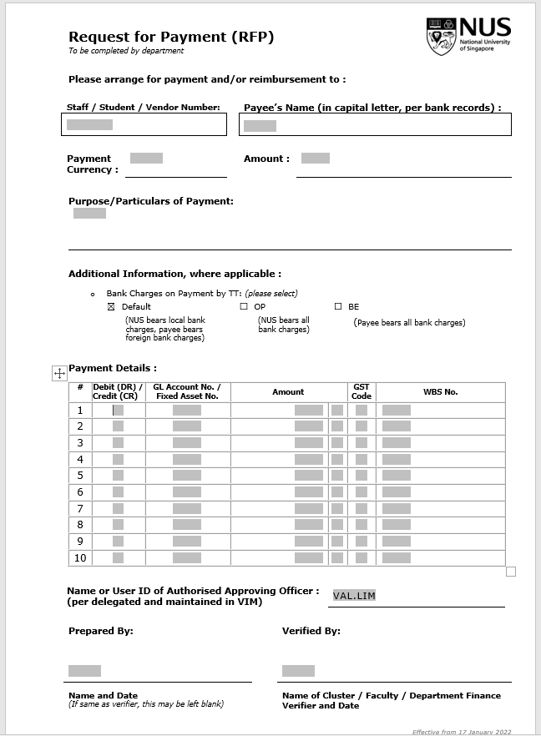
- GL Account (Annex A)
- Sub-total of amount by expenses/GL
Student to input:
- Student ID
- Payee’s Name (Student Name)
- Amount (Total Amount)
- Purpose/Particulars of payment
- Name and Date

Field | Value
Student Number | Student ID (AXXXXXXX)
Payee's Name (in capital letter, per bank records) | Student name as per student ID
Payment Currency | SGD
Amount | Total amount
Purpose/ Particulars of Payment | Description of this claim; Conference name and Date, etc
Payment Details | Only need to fill in two columns
- GL Account No./ Fixed Asset No. | Select from the list of GLs (Annex A)
- Amount | Sum of each expenses type (To indicate the Currency)
Prepared By | Student name and Date

- To email CQT Finance BPs at cqt_finance@nus.edu.sg, the soft copy of the RFP form and supporting documents.

Footnote:
- Student can email CQT Finance BPs at cqt_finance@nus.edu.sg, to check on their balance
Leave request to be submitted to CQTPhD prior to travel; leave must be approved before travel.
- For Student Club expenses, to provide the list of people attending the events, CQTPhD to check and confirm that all attendees are club members.
- For Part-time PhD students, please submit your claims via RFP, and not via concur. Do indicate that you are a part-time student when you submit for any reimbursements in the form.
- RFP form template:
- Per Diem Calculator:

Annex A

GL # | GL Long Text | Remarks
7650101 | Student Training | Conference fee/ registration fee¹ - *Local/Online conferences
7650102 | Student Training (Overseas) | Conference fee/ registration fee¹ - *Overseas conferences
7650103 | Accommodation/Subsistence (Student) | Approved trip's hotel expenses (Hotel < 4 stars hotel) / Per diem (Cap at $2K per trip)/ Covid-19 SHN & swab tests ¹
7650104 | Airfare & Transport (Student) | Approved trip's airfare/ VISA/ Ground transport¹
7650125 | Student Scholarship-Other Allowances | Book allowance¹ /  One-time computer allowance¹
7700701 | Miscellaneous Expense | Covid-19 SHN & swab tests (ONLY for new incoming PhD students)
7650126 | Student Scholarship-Overseas Travel (Airf/Tpt) | One-time airfare allowance (Cap at $1.5K)
7600105 | Local Travel | Local transportation claims (Attach PI's approval)
7100103 | Consumables | Lab purchases (Attach PI's approval)
7500103 | Advertising & Publicity | Poster Printing (Attach PI's approval)
7500101 | Hospitality

1: A research allowance of $12,000 for academic travel, a one-off expense towards a computer and purchase of books and software during the period of candidature, subject to prior approval of all expenses.

